1. **So Far:**
   1. Created Spring Boot App.
   2. Enabled Spring Security.
   3. Exposed RESTful API.
   4. Tested through browser and POSTMAN.
2. **Agenda**:
   1. How Spring Security works internally when a request comes from Front-end App or 3rd Party RESTful API Consumers?
3. This following diagram is the flow.  
   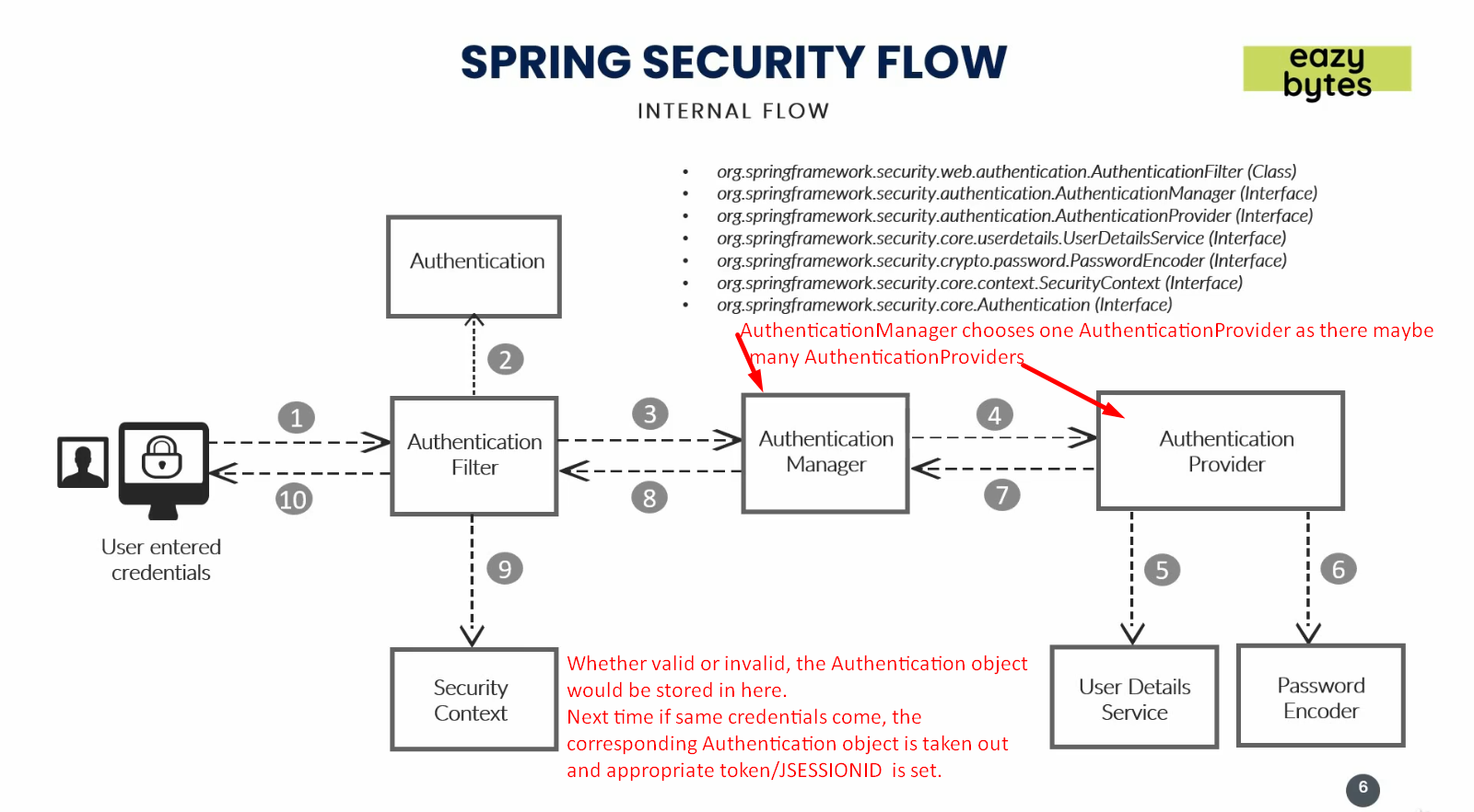
4. **Components in Spring Security**:
   1. **Authentication Filter**:
      1. Present in Spring Security Framework.
      2. Will intercepts all the incoming requests.
      3. It will try to convert the received authentication details such as username, password into **Authentication Object**.  
         This object is a base where all the validation of user credentials will be validated in further steps.
      4. This the base object used to validate user by getting properties values from this object.
      5. Then this Authentication object is passed to **AuthenticationManager.**
   2. **AuthenticationManager:**
      1. There may be many Authentication Providers such as
         1. DB Provider.
         2. LDAP Provider.
         3. OAuth Provider.
      2. Authentication Provider provides the stored credentials against which the received credentials are matched.
      3. So, Basically, AuthenticationManager identifies the appropriate Authentication Provider and sends the Authentication Object to that provider.
   3. **Authentication Provider**:
      1. This is the place where all our business logic related to security/authentication is implemented.
   4. **User Detail Service**:
      1. Schema about the user details.
      2. Actually, the properties such as username, password, OTP etc.
   5. **Password Encoder**: Many such as
      1. No Password Encoder.
      2. Decrypt Password.
   6. **Authentication Object**:
      1. Would hold the followings after validation process.
         1. Is Valid.
         2. What Roles.
         3. What Authorities etc.
   7. **Security Context**:
      1. Whether valid or invalid, the Authentication object is stored in Security Context.
      2. If the same credentials info is passed, these steps are not followed rather Authentication Object from Security context is fetched and user is validated.